**How to create table in AWS DynamoDB**

1. **Create AWS account with your credit card. (You will need IAM)**
2. **Go to AWS Management Console and search for DynamoDB**

**Make sure you are using free tier database (region is Oregon for free tier)**

1. **Click Create Table. Use the following data:**

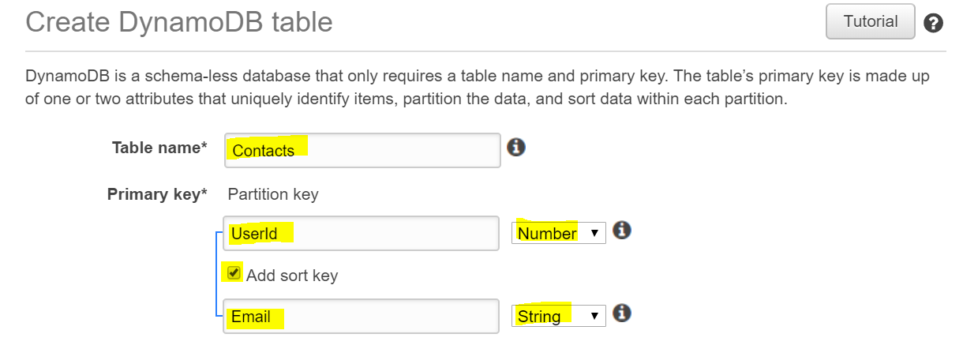

**Click Create.**

1. **Once database is ready Click the Database name > Indexes > Create Index and use the following data:**

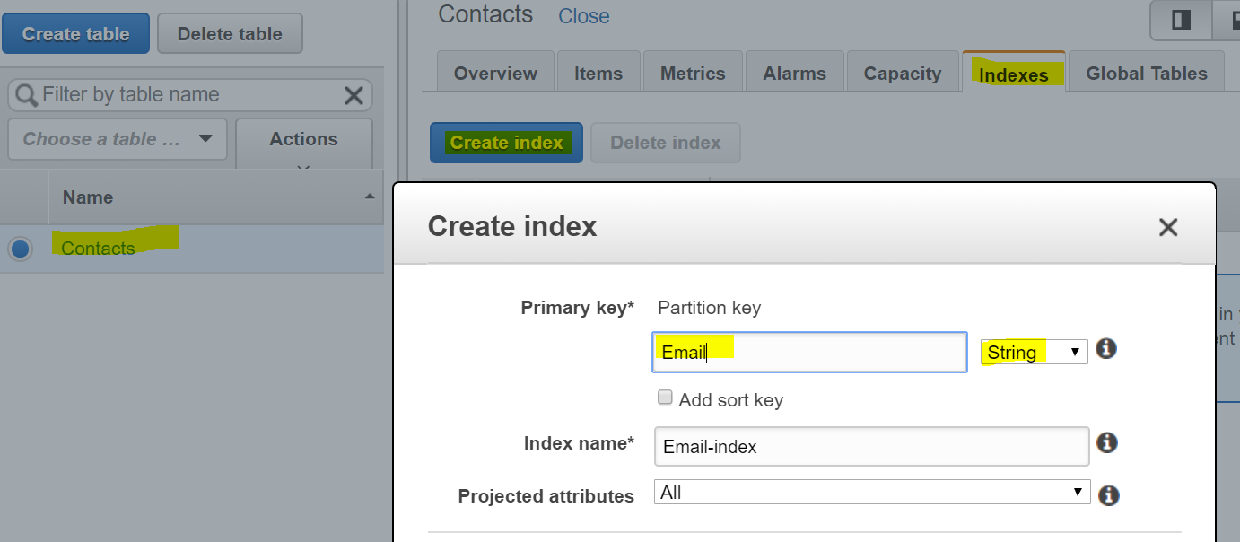

**[Guide for Indexes in Dynamodb**

<https://docs.aws.amazon.com/amazondynamodb/latest/developerguide/GSI.html>]

1. Once Index is created. Click Capacity and reduce the numbers (5) to 1.

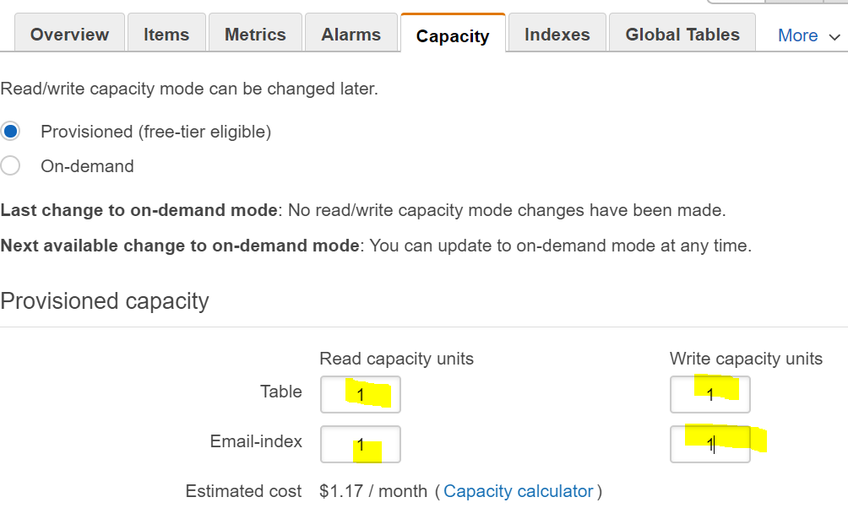

Now Click Save

(This limits read and write capability. See documentation for further details:

<https://docs.aws.amazon.com/amazondynamodb/latest/developerguide/HowItWorks.ReadWriteCapacityMode.html>

Data can read data two ways: scan and query. See guide for further details

<https://docs.aws.amazon.com/amazondynamodb/latest/developerguide/bp-query-scan.html>

1. Your dynamodb database is ready to use.
2. Now follow these steps add two rows of data (each row has four columns)

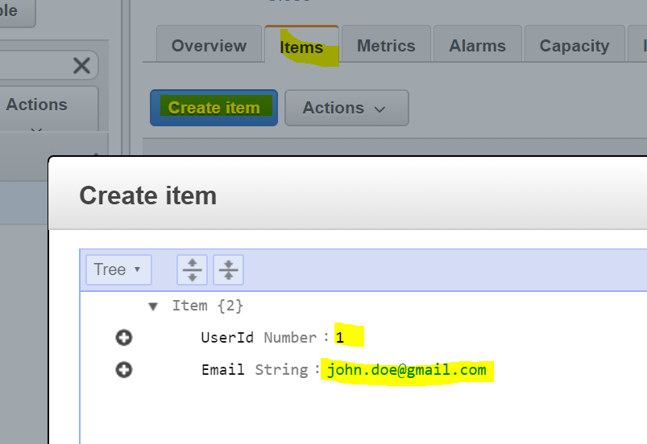

Now click plus sign, choose append, choose string, to add Phone and FullName fields:

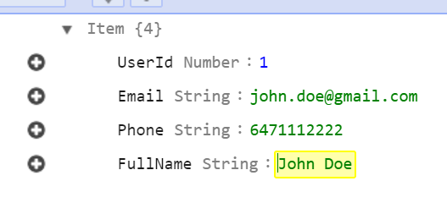

Now repeat step 7 so that you will have two records:

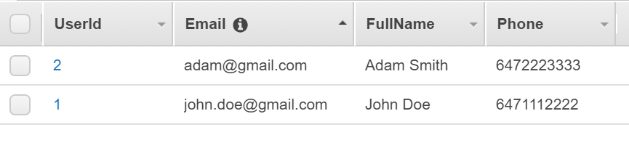

1. You will also need to add a user (and group) for IAM set up

Go to IAM and click Add User

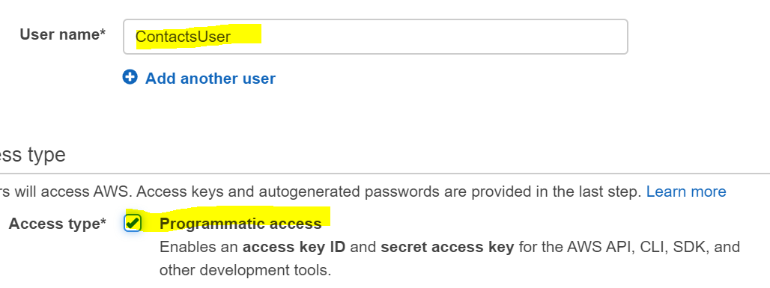

1. Click Next and click Create Group

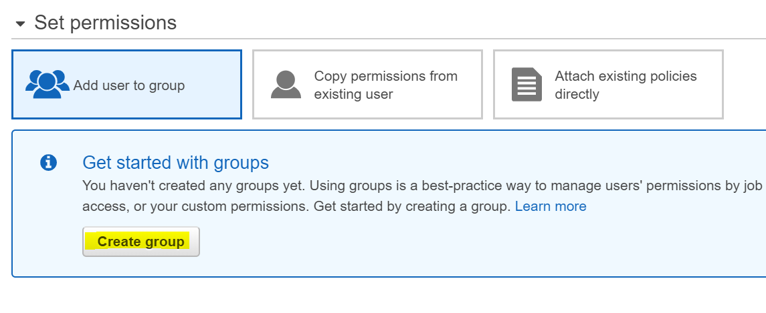

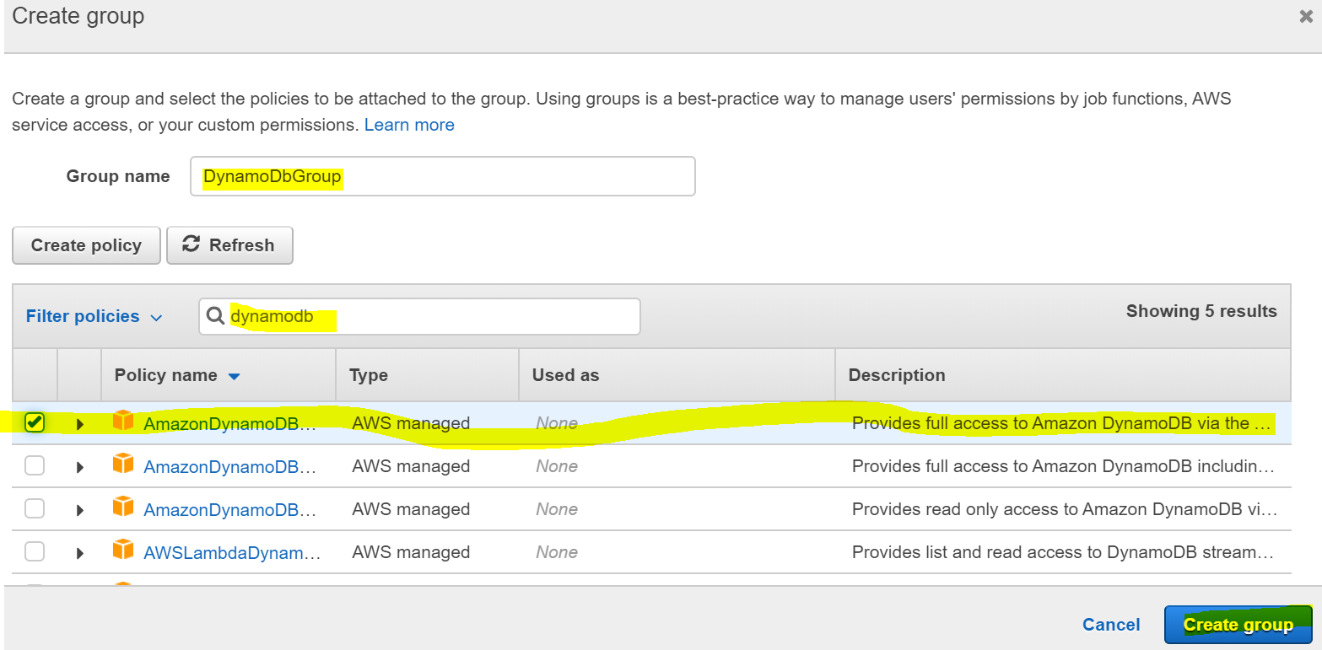

Now your group has full access to dynamodb.

1. Now save this id and access key

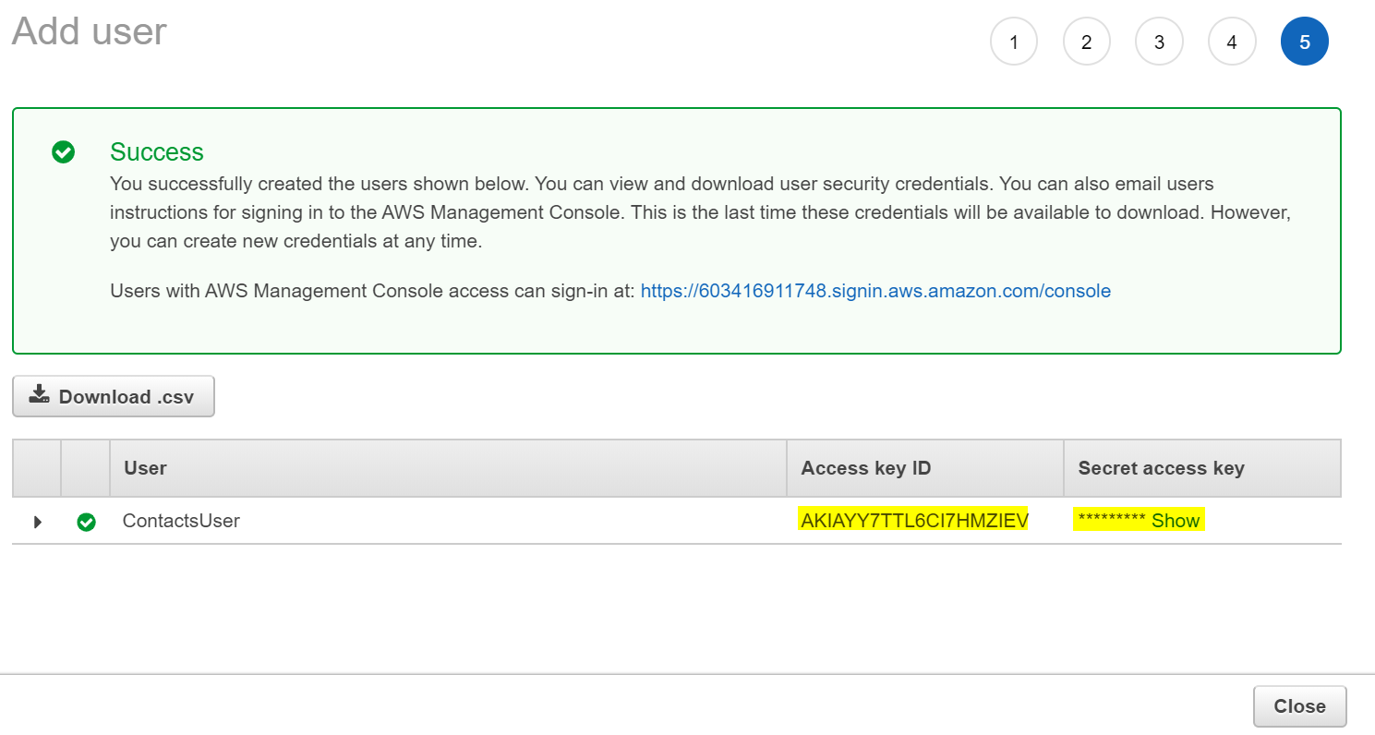

The id and access key will be used later.

The end